**UTILIZATION OF ALGORITHMS, DYNAMIC PROGRAMMING, OPTIMIZATION**

|  |  |
| --- | --- |
| DATE | 16 November 2022 |
| TEAM ID | PNT20022TMID46949 |
| PROJECT NAME | Classification of arrhythmia by using deep learning with 2-D ECG spectral image representation |
| MAXIMUM MARK |  |

**UTILIZATION OF ALGORITHMS**

Our proposed algorithm named Effective Resource Utilization Algorithm (ERUA) is based on 3-tier cloud architecture (Consumer, Service Provider and the Resource Provider) which benefits both the user (QoS)

and the service provider (Cost) through effective schedule reallocation based on utilization ratio leading with the to better resource utilization. Performance analysis made existing scheduling techniques shows.

Keywords: Cloud; Service Request; Service Provider; Consumer; Scheduler Units .

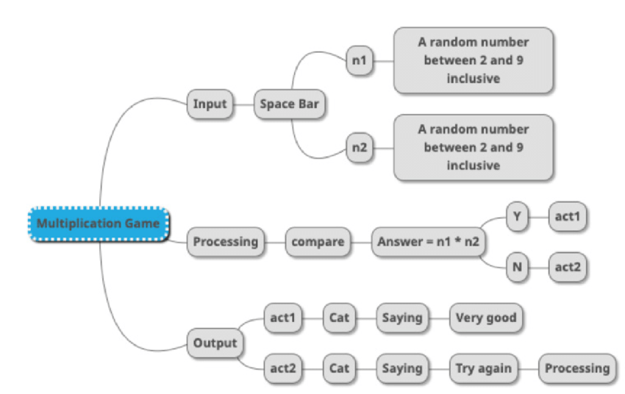

**DYNAMIC PROGRAMMING:**

Dynamic Programming is mainly an optimization over plain [recursion](https://www.geeksforgeeks.org/recursion/). Wherever we see a recursive solution that has repeated calls for same inputs, we can optimize it using Dynamic Programming. The idea is to simply store the results of sub problems, so that we do not have to re-compute them when needed later. This simple optimization reduces time complexities from exponential to polynomial.

For example, if we write simple recursive solution for [Fibonacci Numbers](https://www.geeksforgeeks.org/program-for-nth-fibonacci-number/), we get exponential time complexity and if we optimize it by storing solutions of sub problems, time complexity reduces to linear.

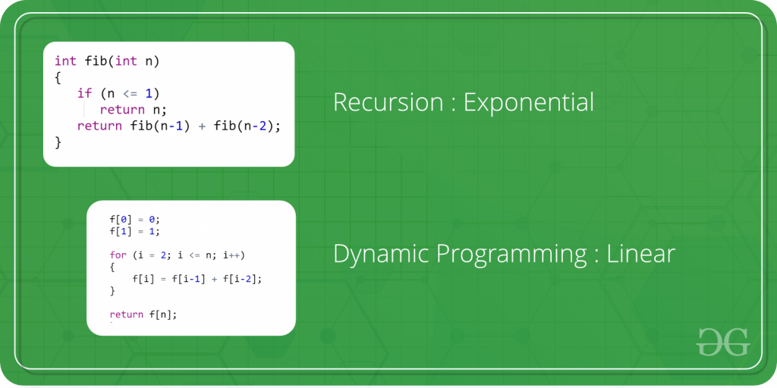

**OPTIMIZATION:**

optimization is the act of changing an existing process in order to increase the occurrence of favorable outcomes and decrease the occurrence .

Distinguishing features of optimization as a mathematical discipline: descriptive −→ prescriptive equations −→ inequalities.